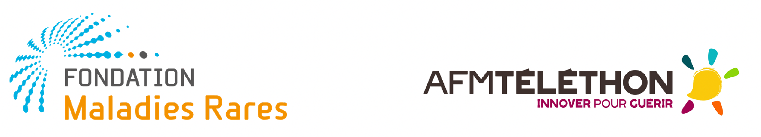

CALL FOR PROPOSALS 2021
Appel à Projets Filières de Santé Maladies Rares (FSMR)
« Preuves de concept thérapeutiques innovants »

PROPOSAL FORM

Project identification
Title
Duration
Requested budget
Category | Category of the POC (chemical entity, repurposed molecule, biologics, other…) :  Level of maturity of the POC (in vitro, in vivo, clinical…) :  Development of the POC : Yes/ No  Maturation of the POC : Yes/ No  Rare disease group and/ or Rare disease (with Orphacode) :
FSMR(s) involved in the project

Non-confidential abstract in English (1500 characters including spaces)

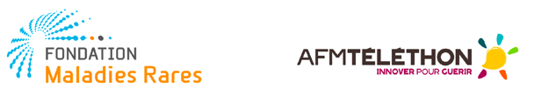

Résumé non confidentiel grand public en français (1500 caractères espaces compris)
Fondation Maladies Rares and AFM-téléthon may use this abstract for their communication.

Principal Investigator (PI) Identification: belongs to a French research team, affiliated to academia and/ or to clinical/ public health sector
Title
NAME
First name
Email
Phone
Institution
Department
Research team
(Name – number)
Address

CV of PI (max. 1 page)

Filière de Santé Maladies Rares (FSMR) involved in the project
Title
NAME of the Coordinator
FIRSTNAME of the Coordinator
Email
Phone
Institution
Department
Address

If applicable: 2nd Filière de Santé Maladies Rares (FSMR) involved in the project
Title
NAME of the Coordinator
FIRSTNAME of the Coordinator
Email
Phone
Institution
Department
Address

Scientific partners
NAME Firstname | Title / Status | Competence and experience in the field of the proposal | Lab / Research unit

Excluded reviewers
N° | Reviewer Name | Structure / Affiliation | Explanation
1
2

LETTER OF SUPPORT FROM THE COORDINATOR(S) OF THE FSMR(S) INVOLVED IN THE PROJECT (max. 1 page for each FSMR) :

Please describe here :
What is the link between the PI and the FSMR ?
Does he/ she participate to FSMR Working group, which one ?
How and why this project matches with the strategy of the FSMR ?

Signature of the Coordinator of the Filière de Santé Maladies Rares :
PROJECT DESCRIPTION (5 Pages max.)

01. Need for research rationale: description of the unmet need that is addressed by the proposed work; present state of the art, recent insight from literature, preliminary/previous results obtained (max. 1 page)

02. Research question(s), originality of the question, main and secondary hypothesis for the purpose of validation or maturation of the proof of concept (max. 10 lines)

03. Soundness and pertinence of the solution and the approach: innovative aspects, originality, novelty, collaboration with the FSMR(s) involved (max. 10 lines)
03.1 If applicable: the relevance of FSMR’s collaboration in the project, and consistency with the strategies of FSMRs (max. 10 lines)

04. Quality of the research: research strategy, study type, methodologies presentation and justification (max. 2 pages)

05. Quality of the project implementation: feasibility of the project (description of stages and milestones, financial issues), synergy between partners involved, access to patients; Description of expected clinical development and expected partnership with industrial companies (if relevant) (max. 1 page)

06. Effective measures to protect, exploit and disseminate the project results, to communicate the project, to manage research data and secure the access of treatments for patients. Indicate freedom to operate of therapeutic compound developed (max. 15 lines)

07. Bibliography

08. Tasks, timeline, budget
Global Amount for the Project | XX Euros
Synopsis
In few words
Timeframe

Total budget
Including subcontracting activities⁽¹⁾

Amount requested for Salary⁽²⁾

Amount requested for Consumables⁽³⁾
Amount requested for Equipment⁽³⁾

Amount requested for Travel⁽⁴⁾

Additional source of funding ⁽⁵⁾
(1) Subcontracting activities may represent a small part of the total budget requested; Please detail who will perform subcontracting activities internally and externally
(2) Please detail number of person months (PM), qualification (Si: scientist, e.g. postdoc; PhD: PhD-student; N: non-scientist, e.g. technician; Ot: other) and € requested
(3) Please detail what and € requested
(4) Please detail reason, destination and € requested
(5) Please detail source, status (requested or received) and amount

GENERAL DATA PROTECTION REGULATION

In the framework of this form we collect Personal Data freely provided by the user including (but not limited to): name, email address, and any other details specifically asked in the survey. We do not share personally identifiable information with unrelated Third Parties. However, we may disclose, transfer or share your Personal Data - anonymized or in its original format- with certain third parties without further notice to you, only for reasons related to the purposes of this survey.

I agree with the following conditions:
Information and Data protection conditions
The information of this form will be used for this purpose only and may be shared within Fondation Maladies Rares or AFM-Téléthon or external experts. The information you should provide includes personal data referred to contact details, such as your name, email address and phone number. Personal data will be collected to allow contacting for further details, if needed. No sensitive data will be collected.
All the collected data will be kept confidential and will not circulate beyond Fondation Maladies Rares, AFM-Téléthon and external experts.
All the information will be made available in an aggregated manner (e.g. cumulative data and statistics).
Fondation Maladies Rares will be responsible for the collection of personal data (see Privacy policy). Fondation Maladies Rares will be responsible for processing the personal data.

DECLARATION

- I have read the above information and:
I authorise the processing of personal data, in compliance with the European General Data Protection Regulation, Reg (EU) 2016/679 for the specific purpose they are collected (any communication of personal data to private or public subject will be allowed only for the specific purpose they are collected).
I authorise to be contacted for involvement in future collaborative initiatives, which might fall within the scope of my research activity.
I authorise to be contacted for dissemination and communication activities (e.g. newsletters, invitations to meetings).

Signature of the PI

